Partner Sections Roadmap Toolkit

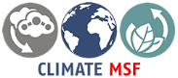

Compiled by Aleksandra Wojtaszek
With collaboration of the MSF Climate Smart Team and Arup
Brussels, September 2024

Table of Contents
For whom is this document for and how to use it? 2
Why do we even talk about environmental roadmap? 3
Want to build your Partner Section’s roadmap? 4
What a Green Team is and should I have one? 5
Climate Roadmap Strategic Framework – Prerequisites 6
Framing 6
Scoping 8
Planning 9
Asking yourself if other Partner Sections already built their roadmaps? 11
Pondering over how my Partner Section can implement those mitigation actions? 12
And how do I prepare my colleagues for the changes? 12
The ADKAR Framework for Change Management 12
Vision-Setting for Change 12
Awareness 13
Desire 13
Knowledge 13
Ability 13
Reinforcement 13
So much work. Who can support me? 13
What are the different tools and resources that I can use for the implementation? 15
Commonalities between different Partner Sections’ roadmaps 16

For whom is this document for and how to use it?
The present document and its attachments are aimed at equipping MSF Partner Sections (PS) with tools, templates, materials and ideas needed to create or update their decarbonization roadmaps, as well as those needed to start implementing the various activities making part of such a roadmap. It’s not intended that the MSF Operational Centers, the MSF European Supply Centers or the people working in the field operations of MSF use this document for the above-mentioned reasons.
Any employee or associative member of those PS interested in environmental topics or directly involved in the creation, update or approval of a PS roadmap can make use of this toolkit. It can be a team leader or any other member of the Green Team, a volunteer or a trainee collaborating on CEH (Climate & Environment Health) / Planetary Health subjects, a PS Climate Ambassador or Focal Point, a person designated by the PS governing bodies to coordinate the climate and environment efforts or a representative of such a governing body that would like to understand the process of creating and deploying a climate roadmap at MSF.
As the constituent parts of this toolkit are independent one form another, any of those aforementioned readers can just focus on one part of the toolkit based on their needs. Otherwise, you may just want to scroll over the toolkit to search for the tips, visualizations or recapitulative paragraphs that best suit your needs, and that are made visibly easy to spot while scrolling. Finally, for any Partner Section collaborator who really searches for more general context information on CEH, they can refer to this additional document.

Why do we even talk about environmental roadmap?
MSF recognized its commitment to mitigating negative impacts of the climate changes already in 2020 by establishing the Environmental Pact, endorsed by the International General Assembly and stating that “A pact is distinct from a motion or a recommendation. The authorship and ownership are shared between associative and executive and it represents a higher level of consensus and commitment, offering specific guidance to inspire accountability.”
Consecutively, in December 2021 MSF had made a pledge to reduce our total carbon emissions by 50% by 2030.
3 December 2021 - “The Full ExCom agrees to collectively set a movement-wide carbon reduction target of 50% by 2030.
Each Institutional member (IM) is expected and encouraged to develop individualized plans or Road Maps to work toward this target, and it is acknowledged that not all IM's will achieve results in the same way or at the same pace. The spirit underlying this vote is that all IM's strive to reach the target.
In order to facilitate progress reporting, IM's should establish a baseline using 2019 carbon emissions data, and report in a standard comparable manner on a (min.) annual basis (it is recommended to use the Climate Smart Environmental Toolkit).”

And, practically speaking, what is the roadmap?
The roadmap helps to:
- Set objectives a given MSF Institutional Member would like to achieve,
- Identify different actions that might help to reduce carbon emissions or any other negative impacts MSF might have on climate,
- Define resources, people and money, needed to implement those actions,
- Agree on possible timelines to start and accomplish those different actions,
- Pick up interdependencies with other internal processes, policies, guidelines, teams,
- Visualize targets, soft and hard KPIs (Key Process Indicators), assigned to each activity,
- Prioritize the work,
- Spot any gaps,
- Build a strategy towards carbon emissions reduction,
- Share the vision with others,
- In case of necessary reporting on carbon emissions’ reduction efforts, can be used as a basis for a monitoring/reporting tool.
In this document we recommend using a specific template of a roadmap but we acknowledge that it can take any other form, e.g. CAPA, Change Action Plan Actions, listing the activities to be embarked on in order to achieve common goals. In any case, before even starting to create the roadmap, the PS should make their decarbonization-related objectives clear. While defining the objectives, it’s paramount to remember that those should be SMART:
Specific – you need to know what you want to achieve, through which means, with whom, by when, within which budget and how you’ll measure the success.
Measurable – it’s crucial to be able to set completion stages and targets.
Achievable – while ambitious, your objectives should be such that your entity can actually reach them within set limits including human and financial resources as well as time boundaries.
Reasonable/Relevant – the objectives should align with your entity’s overall strategy and vision you share with your employees/members.
Time-bound – from the moment of setting the objective, it should be transparent by when we would like to meet it in order to be able to measure completion and success.

Want to build your Partner Section’s roadmap?
Here are the steps. It’s up to you to judge whether the proposed methodology suits your needs and is adequate to your Partner Section’s ways of working. Also, the steps’ order can be changed according to the maturity level of your Partner Section’s employees, members and management team.
Order # | Step Description
1 | Building the Green Team/Climate &Environment taskforce (TF)
2 | Calculating your current CO2 emissions according to Climate Smart carbon accounting methodology and using the Environmental Impact Tool (EIT)
3 | Distributing roadmap building process roles inside your PS and the Green Team/TF
4 | Agreeing on the process timelines, common vision, objective(s) and ways of working
5 | Searching for ideas of mitigation activities based on the CO2 emissions’ calculations
6 | Engaging key stakeholders including Climate Ambassadors/Focal Points
7 | Brainstorming on the different proposed ideas of mitigation activities
8 | Agreeing on the final list of mitigation activities
9 | Voting on the priority of the mitigation activities
10 | Assigning roles & responsibilities towards each activity
11 | Defining targets, metrics, KPIs for each activity
12 | Proposing activities’ implementation timeline
13 | Agreeing on monitoring and reporting process and timeline
14 | Getting your PS management team approval
15 | Deploying communication, education and change management activities to promote the roadmap and its implementation within your PS
16 | Monitoring and reporting on the progress of activities’ implementation

What a Green Team is and should I have one?
In different parts of this document references are made to the Green Teams. We find an extensive definition of a green team at MSF on one of those teams’ SharePoint. “The Brussels Green Team is a voluntary group of staff who lobby to reduce the environmental impact of the Ixelles office building and its staff activities.” Green Teams can be established at all levels of the MSF movement, also at Partner Sections’ level where they can become fundamental to engage Partner Sections’ members and collaborators, promote climate-friendly initiatives, implement and follow up on the mitigation actions. The chosen naming convention is not set in stone. If you think that such a team should be rather called a green/climate taskforce or even a climate working group and follow standard ways of working of such structures, just opt for the one best suiting your PS working culture.
For the purpose of this toolkit, we presume that Green Teams would be created and officially recognized before even starting to build a roadmap, as they would be one of the main actors in this process. Such team should ideally have a team leader that would coordinate the team’s actions. If you seek to collaborate with other Green Teams or would search an advice on how to create one, you can join the Green Teams SharePoint group.
On top of the Green Teams, each MSF Institutional Member should dispose of the necessary structural roles with a clear mandate to implement mitigation activities expressed in the roadmap. People endowed with such roles should take part in the roadmap building or updating process. These individuals can but do not have to be members of the Green Teams. The difference between other, voluntary-based roles in the Green Team and the structural roles would be that the latter would be empowered to discuss and push forward changes at required hierarchical levels of a given IM. How those structural roles would be incorporated depends then on each entity’s organization, capacity, needs and opportunities. It was estimated by climate & environment actors and supported by the Core ExCom that, at a very minimum level, each entity should dedicate 0,1-0,2 FTE (Full Time Equivalent) for either calculating its carbon emissions fully independently or collaborating with an MSF central carbon accounting capacity in making those calculations for a given IM. Another key figure would be a coordination role for all the climate and environment matters, securing the delivery of a PS roadmap, assuring the link with other MSF entities and a successful deployment of the mitigation actions that would lead to the effective accomplishment of the 2021 pledge of reducing all IMs emissions by 50% by 2030. On the other hand, you could also opt for a distributed approach where different teams, making part of a given MSF entity, officially designate some of their members to spend part of their working time on the climate and environment topics. In comparison to the voluntary contribution to the Green Team’s work, such collaboration should be officialized by an update of the position’s Terms of Reference. If a distributed approach is chosen, then a specific Partner Section climate and environment taskforce could be created to ensure a constant and thorough collaboration of the different teams’ representatives.
Definitions and some basic principles explained, let’s now pass to the actual process of creating a roadmap.

Climate Roadmap Strategic Framework – Prerequisites

The MSF Climate & Environment actors, supported by external consultants have developed a complete step-by-step methodology of building a roadmap by MSF Partner Sections. This process requires commitment of the different levels of Partner Sections’ hierarchy, the time and the human resources. When it comes to the implementation phase, investments will be needed, to what extent, it depends on the choices made at the stage of building the decarbonization vision, strategy, tactics and putting all ideas together.
A non negligeable aspect of the roadmapping exercise is a reflection on the change acceptance levels of each Partner Sections, as the aim of the process is a behavior change ultimately leading to reducing CO2 emissions. Some pre-reading on the change and change management process is therefore also advised. You’ll find advice on possible materials and support in the Implementation Guidance.
When the above is addressed, we can focus on the roadmapping exercise strategic framework. The proposed methodology of constructing an actionable climate roadmap for MSF Partner Sections comprises three main stages:
Framing -> Scoping -> Planning

Framing

The framing part consists of a set of actions to define the roadmapping goals, related strategy, resources needed, ways of working and the general framework. The decarbonization vision including the underpinned behavior change should already be set before launching the framing process. Once those elements are identified and agreed upon, one may pass to the actual creation of the roadmap that, according to the proposed methodology, should consist of four areas: projects & programs, education & training, network & relationship and strategy & governance. Those four categories of mitigation actions constitute the building components of a shift towards a sustainable behavior, as shown on below visualization.
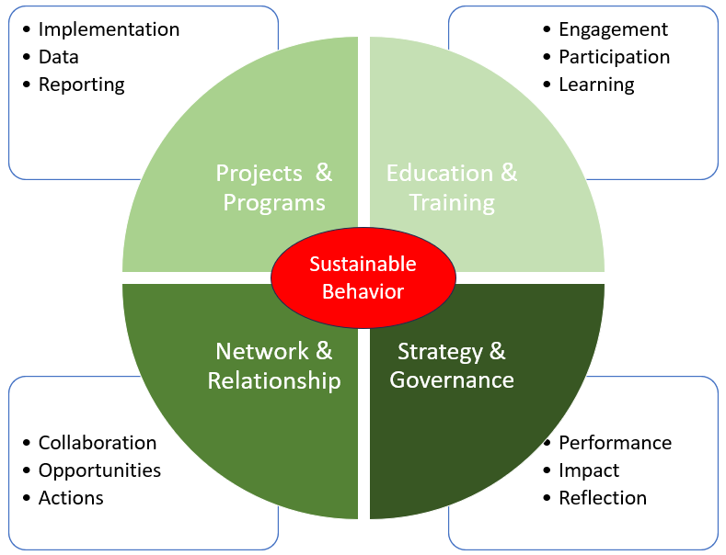
Referring to those four areas, first, a strategic planning of the different phases of the process should take place, including setting of the governance mode, foreseeing the time of reflection, imaging the future implementation impacts and planning for monitoring and evaluation of the outcomes. The monitoring part should be based on the common carbon accounting methodology. This phase involves also thinking about any policies or guidelines that would need to be adapted or reworked following the decarbonization actions.
The second pillar concerns the networking and relationship building efforts that help in defining opportunities and specific actions that will make up the roadmap. It’s also where the communication strategy can help to tighten the collaboration between different teams and individuals that will contribute to achieving the foreseen goals.
The next set of roadmapping activities is the one that needs to be deployed throughout the whole process – engagement and participation through organizing educational and other events, then learning through the trainings best designed to support the change.
Finally follows the actual implementation of the identified activities that can be part of separate, specific interventions, projects or programs. The available data analysis refers here to gathering and analyzing output data of the aforementioned activities and reporting on them on an annual basis.

WHAT TO AVOID: The experience built so far by the MSF Climate & Environment actors supporting Partner Sections shows that the main gaps in the framing stage of the roadmap building process involved:
- No sufficient time to work on climate-related topics: when engaging your colleagues in the roadmap building, make sure that they’ll have enough time to stay engaged throughout the process. Clarify the possible availability of each engaged person in advance and, when possible, for the whole duration of the process.
- Missing reflection time before starting the process: engage the people early enough so that they have the time to gather ideas, brainstorm on them in smaller groups and define who could be engaged on those different actions.
- No strategy in building the Green Team responsible for the roadmap creation: make sure you know what the possible areas of influence of each team member are and that you cover enough of your Partner Section’s teams to reach a consensus and an actual change.
- Templates not shared enough in advance to let the people reflect on how they would like to frame their ideas: all templates related to the roadmap exercise are shared within this toolkit as attachments/links. Distribute them well in advance so that people can prepare for the different meetings and activities.
- Influencing between Green Teams members or between Partner Sections: as far as it is good to learn from others’ experience and discuss different options, make sure that the members of a green team are not under too much of influence of other team members or of other Partner Sections that have already built their roadmap. It can limit the creative part of the reflection process.

Scoping
Once the work is framed and all the involved parties are aware of this framework and applying it, the team responsible for building the Partner Section’s roadmap can get down to the scoping phase.
Sitting to the scoping work, first, all the people involved should be made aware of the common vision and the main outcome expected from the roadmapping exercise. Once this is clear, the team can really start gathering all the ideas of both the activities that will make part of the roadmap and of the specific objectives related to them, being a translation of the vision into specific action items.
While thinking about the activities that you would like to add to your roadmap, bear in mind that, in front of the challenges that the climate changes bring, there are two types of activities that an organization can opt for:
- Adaptation activities, that work on enhancing the resilience to the already faced negative impacts of the climate changes. This kind of activities should not be part of the roadmap. First of all, it’s because roadmapping exercise is a process of strategic planning at a long term. Secondly, this kind of activities is more relevant to the MSF field work.
- Mitigation activities are those aiming at preventing further negative impacts of the climate change to develop and affect MSF patients, our work and the environment. Those activities should become your focus while building your Partner Section’s roadmap.

WHAT TO AVOID: The experience built so far by the MSF Climate & Environment actors in supporting Partner Sections shows that the main areas for improvement in the scoping stage of the roadmap building process are:
- The scoping and framing phases need to be clearly differentiated and delimited. While scoping, you’ll list the mitigation actions aiming at reducing your entity’s carbon emissions in a roadmap form. All the preparatory actions – agreeing on vision, goals, roles & responsibilities, gathering data, engaging stakeholders, including management team – are part of the framing. Then, monitoring and reporting should be treated apart, as either attributes assigned to each mitigation action or become part of the annual planning and yearly decision-making cycles of your Partner Section activities.
- Creating your roadmap and defining its specific actions is neither about writing down the Green Team’s Terms of Reference. Different PS teams, including management, representatives should be included in the process and then follow up on the implementation of those actions by those different teams. It does not exclude the fact that some activities might be specifically assigned to the Green Team, e.g. the engagement events.
- While putting down the mitigation actions in your roadmap, try to be as specific as possible. As an example, instead of just mentioning an update of the procurement policy, try to already think how you would like to update it. You can then rather propose to add sustainability criteria for the 10 most often purchased office materials by your PS.
- Always think about the activities on which your Partner Section has real impact. You are maybe recruiting people that will work in the field and thus will travel but those trips will be taken into account in the carbon calculations of the OC for which the person will be working.
- Avoid including mitigation actions that might require some speculations as carbon offsetting or investing in the so-called green cryptocurrencies.

Planning

The last phase consists of planning, in the sense of defining the practicalities for each of the identified actions. At this stage, you’ll need to respond to the below questions:
- Who will work on the implementation of the defined actions? You might use here the RACSI methodology defining who will be: Responsible – Accountable – Consulted – Supporting – Informed. In other words, you need to think about roles and responsibilities related to each action, making sure you include people that can implement a change but also those that will be able to decide that such a change can/should happen and those who could support you or that should be consulted as they might change your initial idea.
Practical Hint: Whom you involve in your decarbonization efforts is a very important question. While looking into some successful examples of the mitigation actions’ implementation, we’ve come to a conclusion that having one or a small group of convinced and motivated allies, ideally positioned in roles where they could have some influence on the decision-making processes inside your PS, can dramatically speed up and facilitate the behavior change. Here are three examples of that. MSF Canada, well known for being dedicated to climate and environment considerations, has integrated climate lens into all its job descriptions. Other example may be MSF Germany commitment to the decarbonization mirrored in having a dedicated Sustainability Project Manager and an efficient Climate Ambassadors’ network that smoothens the process of implementation in different teams. And finally, the example of the MSF Italy team that puts efforts to receive a LEED Gold certification for the way they renovate their new office building, thanks to a group of motivated people.
- What is the prioritization in between the different actions? What are the most urgent topics or the quick-wins that will let you convince and engage more people? What are the interdependencies in between your activities? Here, the MoSCoW methodology might come at hand, according to which you can categorize your activities into those that: Must happen - Should happen - Can happen - Won’t happen. Don’t be surprised by the last option. The fact that you will come up with some ideas in the scoping phase does not necessarily mean that all those ideas will be put into action or, at least, not immediately.
- How much time it’ll take to work on the different areas and activities? By when would you like to see your activities being implemented? It’ll be linked with the prioritization and so the previous set of questions. You may add one more to them, are there any major events (board/high-level executive meetings/yearly planning events) affecting your agenda? The Gantt chart provides a good visualization of the timelines and dependencies within your planned activities.
- How will you measure the success of the defined change action items? The activities that you’ll list in your roadmap should bring a change to the organization. You must be able to measure this change and define at which point the change would be satisfactory, would respond to your strategic objective. You should set targets for each activity and agree with other people working on the roadmap with you at which point you’d classify an activity as achieving the set goal. You should also assign metrics, hard and soft ones, to your activities depending on whether or not you could get some actual numbers showing the success or whether the indicators of success would be related to something happening, e.g. full approval of a modification of a key policy. Other elements of the evaluation would be the Key Performance Indicators (KPIs) that are similar to the metrics but more tightly linked to a specific activity.
The below image shows the above-described stages of the roadmap building process:
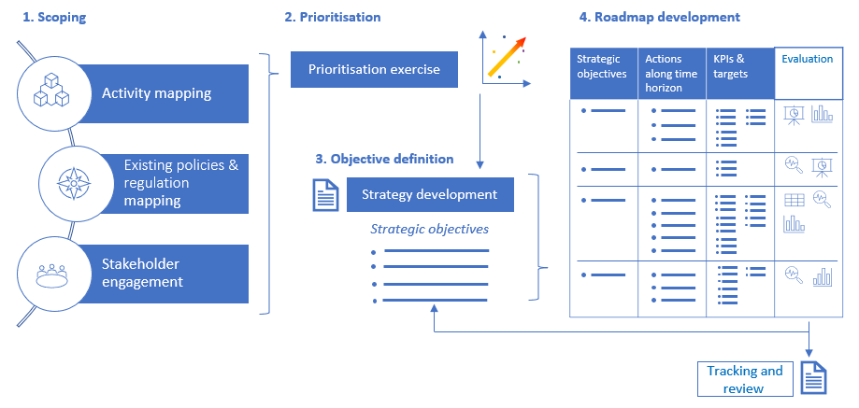
Source: Arup

And below you’ll see how your roadmap can look like in an Excel file:
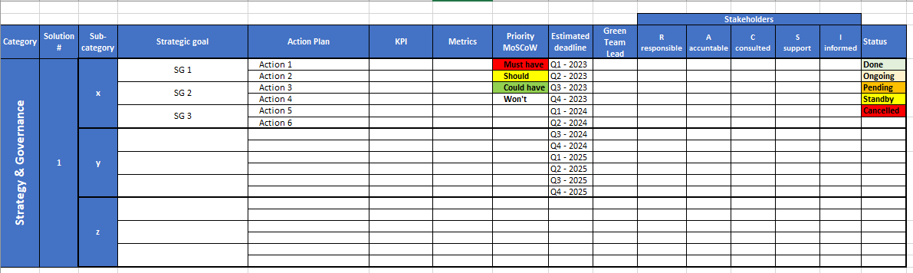
You’ll find a link to the roadmap template here. Don’t hesitate to use it as it is, in order to build your roadmap or adapt it according to your needs, still taking into account the preceding paragraphs. You’ll see those different areas – Strategy and Governance, Network and Relationships, Education and Training, Projects and Programs – are treated under separate tabs. You may also put all those actions together. For sure, in all cases, it’ll be good to accompany the roadmap with some narrative explaining the process you went through, methodology, choices made and people involved.

Asking yourself if other Partner Sections already built their roadmaps?
Here is the link to the folder that contains the most recent versions of the roadmaps of the 6 PS offices: Denmark, Sweden, Norway, Hong-Kong & Taiwan, the US and Brazil.
And here is the link to the table recapitulating all the mitigation actions identified by the above Partner Sections. The list is long as it represents all the pinpointed activities. Don’t hesitate then to filter by specific strategic goals being your PS’ priority or search the actions by key words. The document is meant to provide you with some ideas and compare your choices to other PSs.

Pondering over how my Partner Section can implement those mitigation actions?
Here is the link to the Implementation Guidance listing various mitigation actions for which the implementation plans or pieces of advice were proposed. The list is long as it represents all the identified activities. Don’t hesitate then to filter it by specific strategic goals being your PS’ priority or search the implementation advice by key words. The document is meant to provide you with ideas and additional resources for the areas of your interest. The proposed prioritization reflects MSF Climate & Environment actors’ recommendations but you can choose to give the selected activities yet another ranking.

And how do I prepare my colleagues for the changes?

The ADKAR Framework for Change Management
Multiple models exist for organizational change management. One such approach that can be applied in the context of decarbonization for the MSF PSs is the ADKAR framework. ADKAR here standing for Awareness, Desire, Knowledge, Ability, and Reinforcement, with each element representing an outcome that an individual needs to achieve successful change. A shortcoming of the ADKAR framework for change management is that, in being outcome focused, it assumes that the desired change has already been defined. The change management approach of the PSs would therefore benefit from a preceding step on direction- and vision-setting for change.

Vision-Setting for Change
Before the actual change can be delivered through the ADKAR framework, PSs should define the vision they strive for in decarbonizing and the direction they wish to take in order to realize this vision. The vision should be inspiring and aspirational, motivating employees and stakeholders to take ownership of the decarbonization efforts. It should be communicated in a way that resonates with both the heart and mind, creating a sense of shared purpose. This vision-setting should include a defined set of responsibilities and accountabilities assigned to those that are sponsoring and managing the change. Two actions categorized in Implementation Guidance under the category of ‘Strategy & Governance’ - Creation of the Green Team and Annual Plan Development (Action #49&54) - could support the creation of this vision-setting.

Awareness
One of the focus areas for the PSs should be to raise awareness amongst their members on the need for change and the benefits of decarbonization. These benefits include those available to the PS members themselves, but they can also extend to opportunities for the MSF movement, the humanitarian sector and the world more broadly. Several actions categorized in the Implementation Guidance under the strategic goal of ‘Sensitization’ can promote this awareness, e.g. Environmental Onboarding (Action #32) and including environmental topics in publications and presentations (Action #33).
Available Resources from the Climate and Environmental Health and Mitigation training package
The following information and materials could be repurposed from the above education package to act as onboarding resources:
- Climate mitigation workshop facilitator guide content on “Intro to Climate Science basics” and the differences between climate adaptation and mitigation, alongside the ‘cause-effect cards’, could be used for climate science fundamentals onboarding
- Climate mitigation workshop facilitator guide content on “Human health is directly linked to climate health” and “Climate change and health”, alongside the Climate-Health Event Cards, could be used for onboarding regarding the intersection between health and climate.
- Climate mitigation workshop facilitator guide content on “Displacement and Climate Change” could be used to educate members on the role of climate action in addressing the central humanitarian challenges of the movement within onboarding.

Desire
The PSs must create desire amongst their members to enact the necessary change. Desire can be cultivated by demonstrating the impact that the decarbonization interventions are delivering. Actions under strategic goal of ‘Information Sharing’ within the Implementation Guidance can deliver this demonstration. Some Implementation Guidance actions under ‘Engagement’ can further support this. The actions and examples of MSF education materials which could be used to deliver desire are: In-Person Updates During Office Meetings and Email Updates by the Green Team on Initiatives and Progress (Action #39&37); Idea Campaigns for Staff (Action #36); Climate (Change) and Environment Weeks (Action #30); Participation in External 'Green' Events (Action #31).
Available Resources from the Climate and Environmental Health and Mitigation training package
The following information and materials could be repurposed from the above education package to act as resources showing possible impacts of decarbonization:
- Climate mitigation workshop facilitator guide activities on the brainstorming of mitigation measures and the facilitating fact sheet (climate mitigation solutions by profiles) could be used as the basis for an idea campaign on mitigation actions to be taken within PSs.

Knowledge
PS employees should have the skills and knowledge required to enact the decarbonization actions for which they are responsible. Actions in the Implementation Guidance categorized under ‘Training’ can support this. The actions and examples of MSF education materials which could be used to deliver knowledge are: Environmental sustainability trainings as part of the L&D package (Action #26); trainings for the Green Team on change management and sustainability (Action #27); hosting one training or education event (bi-) monthly (Action #28).
Available Resources from the Climate and Environmental Health and Mitigation training package
The following information and materials could be repurposed from the MSF Education Package for the L&D package on MSF’s processes for GHG impact and improvement:
- Climate mitigation workshop facilitator guide content on “How do we measure our current impact and improvement?”
The best practice case studies on waste management, insulation improvements, and energy meter installation could be repurposed as permanent features of an L&D package used by PSs to help enact these decarbonization interventions, also in the form of spotlights of best practices in decarbonization actions.

Ability
PS members should be provided with the ability to implement the actions for which they are responsible. Members should have access to the necessary resources, tools, and time to enable them to undertake their new actions. Multiple actions within the Implementation Guidance can help to deliver upon this. The actions and examples of MSF education materials which could be used to deliver ability are: SharePoint environmental knowledge base (Action #35); regular meetings held by the Green Team with staff to share ideas on climate actions and to secure engagement (Action #36).
Available Resources from the Climate and Environmental Health and Mitigation training package
Within the Climate mitigation workshop facilitator guide, at the end of the workshop, attendees are asked to ‘pledge’ to be a climate champion, whilst committing to a climate action. This champion pledging ask could become a regular request made at meetings held by the Green Team, thereby providing all PS members with the ability to support in decarbonization actions.

Reinforcement
To reinforce the change made, a supportive environment should be established that encourages the continued adoption of decarbonization practices and technologies. The governance-related actions detailed in the Implementation Guidance for the creation of the Green Team and the hiring of a Climate Focal Point can support this. The bolstering of actions through the offering of incentives and rewards for collaborators can further reinforce the changes. Monitoring and evaluation exercises across all recommended actions in the Implementation Guidance can help to inform when and how to best reinforce practices. Some examples of those actions are: an introduction of the role of the Green Team (Action #49); hiring of a Climate Focal Point (Action #50).

So much work. Who can support me?
Climate Smart MSF is a Transformational Investment Capacity (TIC) project that finishes in December 2024. Until then, you can reach for the team’s support and you’ll find all names and different workstreams on this SharePoint. Beyond that date, you’ll find the below roles in the International Office:
- Monitoring Frame Implementation Specialist
- International Carbon Referent
- Carbon IMs’ Support
- Sustainable Procurement Coordinator
- 2 Suppliers’ Sustainability Assessments Leads
- Logistics & Medical Equipment Items Sustainability Criteria Advisor
Please note that, as of mid-September 2024 only one Suppliers’ Sustainability Assessments Lead role already exists. All the other roles still need to undergo Full ExCom approval. The detailed scope of work and the titles can therefore undercome some modifications. Look for updated information on the central Climate Share Point. You can also liaise with representatives or climate focal points of other MSF Institutional Members, mentioned in other parts of this toolkit.
On top of that, the Mutual Accountability Framework will let you understand how MSF central governing bodies, the Core and Full ExCom, will monitor progress of decarbonization of all IMs.
Finally, the MSF-wide Climate & Environment Landscape will provide you with an understanding of different actors, initiatives, opportunities and gaps identified so far in the climate and environment related topics for the whole MSF movement.

Beside the above, you can get acquainted with what the OCs are doing or planning to do in the climate and environment areas. Some examples of those actions can be found on the below SharePoint pages:
- OCA – Green Elephant Network
- OCB – Climate, Environment and Health movement (CEH)
- OCBA – Passive Design Guide
- OCG - Planetary Health initiative
- OCP – Pacemaker publication

What are the different tools and resources that I can use for the implementation?
Here is the list of useful links:
- Climate Smart public SharePoint
- Carbon Accounting and Environmental Impact Toolkit (EIT) SharePoint page
- Sustainable Supply Chain and Procurement SharePoint page
- Business Travel SharePoint page
- Energy Transition SharePoint page
- Climate And Environment (C&E) SharePoint page
- All MSF Roadmaps resources SharePoint page
- MSF Climate & Environment Landscape SharePoint page
- HACE an MSF Canada based team, Humanitarian Action for Climate and Environment, focusing on climate changes adaptation and advocacy
- GreenTeams SharePoint group
- TIC portal comprising the MSF innovation projects, also those aimed at sustainability (Single Use Items and EcoShift being two examples, the first dedicated to medical single-use products and the other to finding funding opportunities for the climate related initiatives)

Commonalities between different Partner Sections’ roadmaps
According to the 2019 baseline carbon emissions calculations, the biggest source, responsible for 66% of carbon emissions at the Partner Sections, is linked to purchased goods and services, where, more concretely, paper consumption is representing the biggest part. It’s followed by travel representing 19% of the emissions. That’s why, while choosing the activities for your roadmapping process and prioritizing them, you should focus on those related to the aforementioned categories. Respectively, majority of the six PS that shared their roadmaps are convinced that their travel and procurement policies should be reviewed and updated with sustainability criteria with regards to travel and procurement of goods and services. Some of the specific changes to travel practices, mentioned by the Partner Sections in their roadmaps, are related to banning short-haul and/or domestic flights, promoting trains over planes, privileging regional rather than global meetings, avoiding face-to-face meetings with vendors and encouraging communication through digital channels over in-person ones. As it comes to procurement policies, the Partner Sections were specifically mentioning assessing suppliers and purchasing goods locally. The linked, central Climate Smart travel and procurement SharePoint pages will provide you with updated MSF International Travel Policy and Guidance and with the tools necessary for your suppliers’ assessment.
Capital goods (owned buildings, vehicles, IT equipment etc.) account for 11% and the energy consumption for 3% of the PS carbon emissions. Installing solar panels or insulating the building, actions mentioned in three roadmaps, can address both those areas. Norway, Denmark, Hong-Kong and Brazil Partner Sections promoted the HVAC (Heating, Ventilation, and Air Conditioning) systems optimization and installing movement-detecting lights. As it comes to capital goods on their own, two PSs advanced an idea of assessing the change of the office to a smaller one or finding an alternative usage of the unexploited space, being given the changes brought by COVID.
On top of that, all six Partner Sections agree that change management initiatives should be deployed among the employees to prepare them for the changes brought by the mitigation actions aiming at reducing the CO2 emissions. Some Partner sections were specifically mentioning the behavior change management while others were rather opting for organizing punctual events to influence the colleagues.
All PS beside the US one mentioned in their roadmaps quick-wins mitigation activities like regularly deleting e-mails and cleaning up the online archives to reduce cloud storage space and processing times. Another activity, omitted just by the US office, was the proposal to add vegetarian and/or vegan options in their canteen’s menu. Finally, four out of sic PS are convinced that the recycling practices should be still improved.
Five PS think that a priority should be given to monitoring the CO2 emissions according to a common methodology and setting clear annual targets for all environment and climate priorities. The three Nordic PS also highlight the need of collaboration with other Green Teams to exchange good practices and tools.
Sweden, Norway and the US offices advanced the idea of creating a climate-centered communication strategy, at the same time assuring regular environmental statements on external websites. On top of that, Norway, Hong-Kong and Brazil saw a potential in engaging volunteers in the climate actions.

Acronyms and Abbreviations

APU – Amsterdam Procurement Unit
CAPA - Change Action Plan Actions
C&E – Climate & Environment
CEH – Climate and Environment Health
CoP – Community of Practice
COP21 - UN Climate Change Conference
EIT - Environmental Impact Toolkit
ESC - European Supply Center
EU - European Union
FTE – Full Time Equivalent
HACE - Humanitarian Action for Climate and Environment
IM - Institutional Member
IMF - International Monetary Fund
IPCC - Intergovernmental Panel on Climate Change
KPIs - Key Process Indicators
OC - Operational Center
OCA - Operational Center Amsterdam
OCB - Operational Center Brussels
OCBA - Operational Center Barcelona and Athens
OCG - Operational Center Geneva
OCP - Operational Center Paris
OS - Operational Section
MSF - Médecins sans Frontières
MT – Management Team
NDCs - Nationally Determined Contributions
NGOs - non-governmental organizations
PS - Partner Sections
TF - taskforce
TIC - Transformational Investment Capacity
ToT – Training of trainers
UN - United Nations
UNEP - United Nations Environment Program
WaCA – West and Central Africa Operational Center
WG – Working Group
WMO - World Meteorological Organization

https://msfintl.sharepoint.com/sites/OCA-DEPT-DO/SitePages/Movement-wide-carbon-reduction-target.aspx
https://msfintl.sharepoint.com/sites/ocb-intranet/SitePages/Offices/Brussels-ABC-Green-Team.aspx
You’ll find it on the Climate Smart Share Point.
If you are interested in the adaptation topics, Humanitarian Action for Climate and Environment (HACE) team in Canada is providing information, data and support in this area.
To consult the Global Procurement Policy, go here.
Read MSF Carbon Offsets position paper.
If you want to know more about RACSI, refer, for example, to: https://www.interfacing.com/what-is-rasci-raci.
LEED certification for new buildings and major renovations | U.S. Green Building Council (usgbc.org).
For definition and some examples, go to https://www.projectmanager.com/guides/gantt-chart.
https://www.arup.com/
For more information about TIC, consult: https://msfintl.sharepoint.com/sites/msfintlcommunities/tic/SitePages/Home.aspx
In this report, we’ll talk about 5 Operational Centers. WaCA, the 6th OC was created in 2019. The Climate Focal Point was hired in year 2024 as this toolkit was being written. The 2019 baseline carbon emissions calculations and the environmental roadmap of WaCA will only be ready after publication of the report.
For details go to: https://msfintl.sharepoint.com/sites/ClimateSmartMSF/SitePages/MSF-Baseline-2019.aspx
Both the Mutual Accountability Framework and MSF-wide Climate & Environment Landscape documents are being finalized at the moment of handing over the toolkit to the PSs. Look for updates under the provided links at a later stage (second half of October at least).

